1. Find the UMA_Secrets folder in the Project panel  
   (UMA>Content>UMA_Secrets)  
   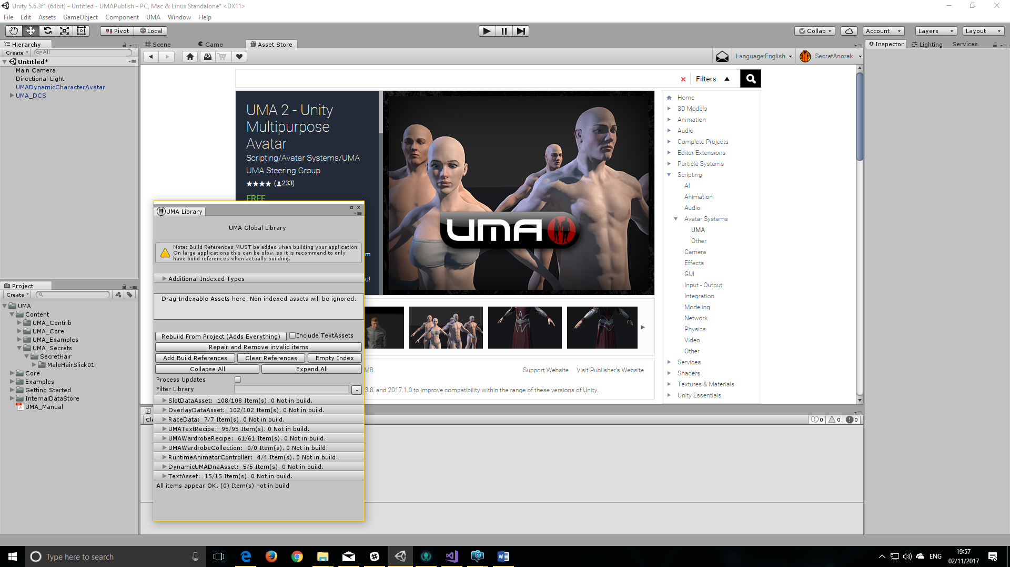
2. Open the UMA Global Library Window from the Menu  
   (UMA>Global Library Window)  
   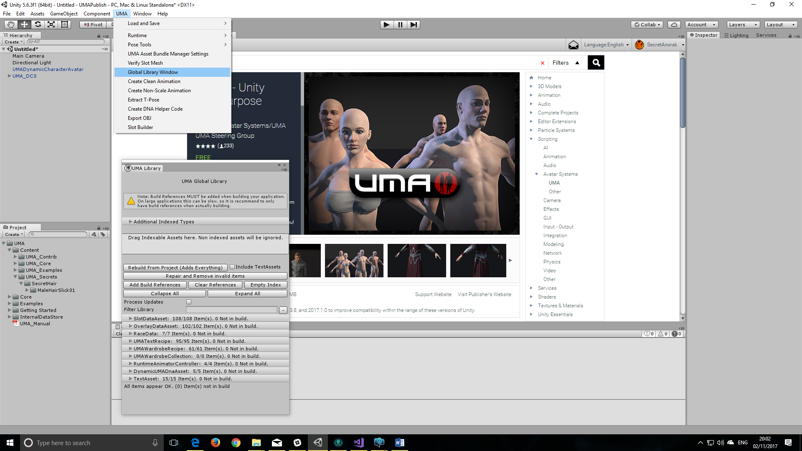
3. Drag the UMA_Secrets folder into the global Library Drop area:  
   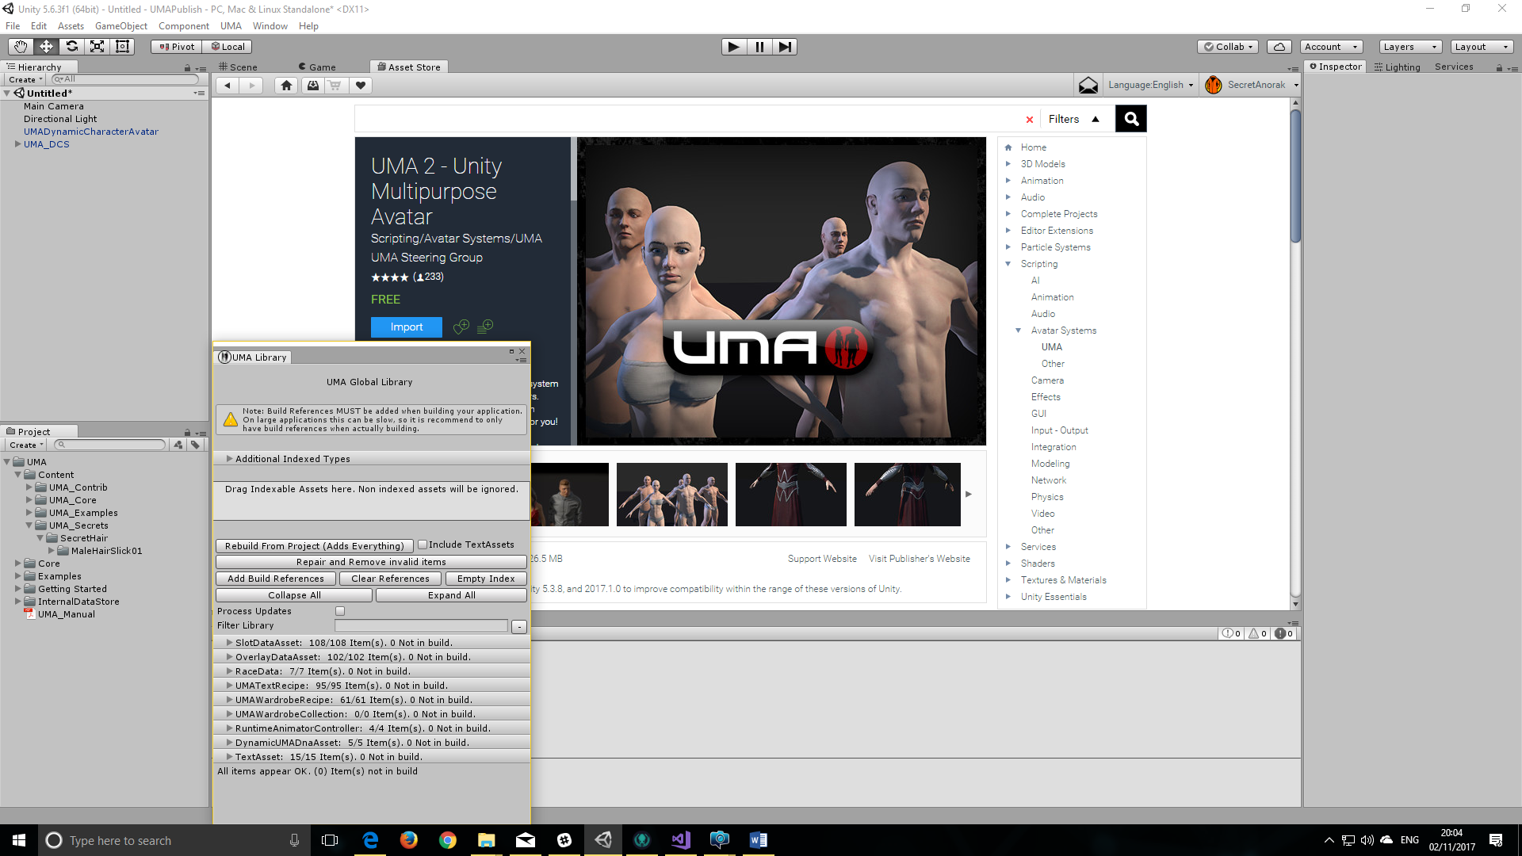
4. Your new asset will now be available for use on any male UMA